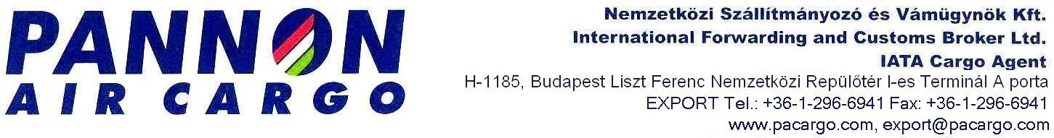

PERMANENT ORDER FOR Customs Clearance DELEGATION
(for direct customs representation)

Company ( Principal )name: ………………………………………………………….………………

Registered office /Address: …………………………………………………….……………………

Customs Identification Number: (VPID/EORI No) …………………………………………………

Tax Identification Number: ………………………………………………………………………….

Bank Account Number (IBAN): .…………………………………………………………………….

Principal’s representative / Name……………………………………………………………………

Position: ………………………………………………………………………………………………..

Phone/Mobile:……………………………………e-mail……………………………………………

Principal’s representative hereby delegates PANNON AIR CARGO Ltd to provide full representation before NAV (National Tax and Customs Administration of Hungary ) in accordance with the Article 5 of Council Regulation (EEC) No 2913/92 of 12 October 1992 (the Community Customs Code), for the Principal, in its the name and on its behalf, in the following customs matters:

- customs clearance (export/import/transit procedures )
- release for free circulation
- calculating customs charges
- representation at examination of goods
- pick-up/collecting the shipment and its documents from the handling agents (both non-EU and EU shipment)
- take over the NAV’s resolution addressed to the Principal
- other services :……………………………………………………………………………….

PANNON AIR CARGO shall charge a fee to the Principal for the services provided.
This power of attorney is valid until withdrawn.

I hereby verify under penalty of perjury that all the data above are true and correct.

Date: ………………..

……………………………………….. .
Principal’s official signature and stamp

Representative hereby accepts the delegation and declares to represent the Principal in the capacity of direct customs representative and shall act in its name and on its behalf.

Date: …..…………… ……………………………………………..
Pannon Air Cargo ‘s official signature and stamp

